*Process Design Document*

ID data to Revisal app

Version 1.0

November 22, 2021

|  |  |  |  |
| --- | --- | --- | --- |
| **Document ID:** |  | **Release:** |  |
| **Revision#** | 1.0 | **Revision Date:** |  |
| **Next Revision Due:** |  | **Information Sensitivity:** | Confidential |



**Document Details**

|  |  |
| --- | --- |
| Solution Document | |
| Project owner | **Manuel Apostol** |
| Project title | **ID data registration automatization** |
| Issue | Version 1.0 |

|  |  |  |  |  |
| --- | --- | --- | --- | --- |
| Review Tracking | | | | |
| **Version** | **Description** | **Name(s)** | **Role** | **Date** |
| v1.0 | Initial draft |  |  |  |

|  |  |  |
| --- | --- | --- |
| Document Approval Flow | | |
| Version | **Approver(s)** | **Date** |
| v1.0 | Vitalie Ciupac | 29.10.2021 |

Table of Contents

1. Introduction 4

1.1. Purpose of the document 4

1.2. Objectives 4

1.3. Process key contacts 4

2. AS IS Process Description 5

2.1. Process Overview 5

2.2. Applications used in the process 5

2.3. AS-IS Process Map 6

2.3.1. High Level AS-IS Process Map 6

2.3.2. Detailed AS-IS Process Map 6

2.4. Additional sources of process documentation 7

3. TO-BE Process Description 9

3.1. SIPOC (Supplier, Input, Process, Output, Customer) 9

3.2. Scope 9

3.2.1. In Scope for RPA 9

3.2.2. Out of Scope for RPA 9

3.3. TO-BE Process Map 10

3.3.1. High Level TO-BE Process Map 10

3.3.2. Detailed TO-BE Process Map 10

4. Detailed TO-BE Process Description (D05) 11

4.1. Process Details 12

4.1.1. Initiate runtime parameters 13

1. **Introduction**
   1. Purpose of the document

The Process Functional Specifications Document outlines the business process chosen for automation using UiPath Robotic Process Automation (RPA) technology.

The document describes the sequence of steps performed as part of the business process, the conditions and rules of the process prior to automation and how they are envisioned to work after automating it, partly or entirely. This specifications document serves as a base for developers, providing them the details required for applying robotic automation to the selected business process.

The Process Definition Document describes the process chosen for automation. "Future WorkForce" has selected ID data to Revisal app as one of the processes for automation, that has been described in detail in this document.

* 1. Objectives

The process that has been selected for RPA is part of the larger project **ID data registration automatization** conducted within the "Future WorkForce" organization, HR department.

The business objectives and benefits expected by the Business Process Owner after automation of the selected business process are:

* *Reduce processing time per ID data intrudusing in the system by 95 %. The duration to process an ID data extraction validation is apx. 30 seconds.*
* *An increase, by 70%, of data accuracy. The CNP extracted with OCL will be verified to be valid (romanian state SSN standards)*

* 1. Process key contacts

The specifications document includes concise and complete requirements of the business process and it is built based on the inputs provided by the **process** **Subject Matter Expert (SME)/ Process Owner.**

The **Process Owner** is expected **to review it and provide signoff for accuracy** and completion of the steps, context, impact and complete set of process exceptions.

The names have to be included in the table below.

|  |  |  |  |
| --- | --- | --- | --- |
| Role | Name | Contact details  (email, phone number) | Notes |
| *Process Reviewer/ Process Owner* | *Vitalie Ciupac* | *vitali.ciupac@fwfcompany.com* |  |

1. **AS IS Process Description**
   1. Process Overview

General information about the process selected for RPA prior to automation.

|  |  |  |
| --- | --- | --- |
| # | Item | Description |
| 1 | **Process full name** | *ID data to Revisal app* |
| 2 | **Process Area** | *Human Resources* |
| 3 | **Department** | *Finance and Accounting* |
| 4 | **Process short description**  (operation, activity, outcome) | *Data from image IDs that are stored in a shared folder is extracted and processed in Revisal aplication. An output report is generated after each ID. (excel file)* |
| 5 | **Role(s) required for performing the process** | *HR team member* |
| 6 | **Process schedule and frequency** | *monthly* |
| 7 | **# of items processes /month** | *~100* |
| 8 | **Average handling time per item** | *3 min* |
| 9 | **Peak period (s)** | *End of month, usually from 20th to 28th day of each month* |
| 10 | **Total # of FTEs supporting this activity** | *2* |
| 11 | **Level of exception rate** | *~20% exceptions ( unreadable data on the ID)* |
| 12 | **Input data** | *JPEG images from a shared folderl* |
| 13 | **Output data** | *Excel file with ID information and status and employee added in Revisal* |
| 14 | **Dependencies**  (upstream, downstream) | *Revisal, Excel and access on shared a folder* |

*\*Add more rows to the table to include relevant data for the automation process. No fields should be left empty. Use “n/a” for the items that don`t apply to the selected business process.*

* 1. Applications used in the process

The table includes a comprehensive list all the applications that are used as part of the process automated, at various steps in the flow.

|  |  |  |  |  |  |  |
| --- | --- | --- | --- | --- | --- | --- |
| # | Application name & version | System  Language | Instance | Thin/Thick Client | Environment/  Access method | Comments |
| *1* | *Revisal* | *RO* | *n/a* | *Client* | *Local desktop* | *Single Sign On* |
| *2* | *Excel* | *EN* | *n/a* | *Client* | *Local desktop* | *Test environment for POC identical with production system.* |

*\*Add more rows to the table to include the complete list of applications.*

* 1. AS-IS Process Map
     1. High Level AS-IS Process Map

This chapter depicts the As Is business process at a High Level to enable developers to have a high-level understanding of the current process.

*Example:*

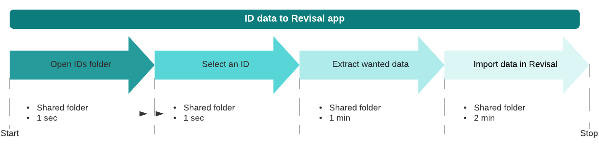

1. **TO-BE Process Description**

This chapter highlights the expected design of the business process after automation.

* 1. SIPOC (Supplier, Input, Process, Output, Customer)

|  |  |  |  |  |
| --- | --- | --- | --- | --- |
| Supplier | Input | Process | Output | Customer |
|  |  | Click below to go to process details  ­Detailed To-Be process description |  |  |

* 1. Scope
     1. In Scope for RPA

The activities **in scope of RPA**, are listed here:

1. *Read id data*
2. *Extract necessary data*
3. *Create new employees in Revisal*
4. *Add status to output file*
   * 1. Out of Scope for RPA

The activities **OUT of scope of RPA**, are listed here:

1. *Not responsible to put the images in the shared folder*
2. *Not responsible to validate the extracted data.*
3. *Not responsible for handling invalide data*
   1. TO-BE Process Map
      1. High Level TO-BE Process Map

This chapter depicts the TO-BE business process at a High Level to enable developers to have a high-level understanding of the future process.

*Example:*

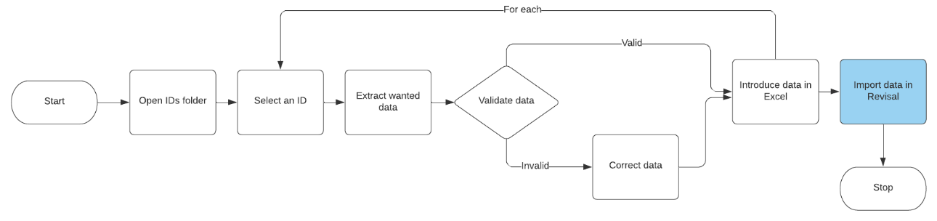

1. **­Detailed TO-BE Process Description (D05)**

This chapter describes the chosen process in detail, which enable the developer to build the process. The individual steps are illustrated in screen shots for reference purposes.

In the following chapters, different colors are used to indicate, what the text is concerned with. This means that:

|  |  |
| --- | --- |
| Color definitions | |
| Black | Used for the overall description directed at the developer |
| Green | Used to indicate that this activity is new or differ from the current process flow |
| Red | Used to indicate that clarification is needed |
| Purple | Used to indicate that the steps are updated in the PDD *after* the first agreement of scope |

* 1. Process Details

|  |  |  |  |
| --- | --- | --- | --- |
| Step | Application | Detail | Screenshot |
| 1 | Shared folder | Accesing "IDs" folder where scanned IDs are located. |  |
| 2 | Shared folder | Select each ID |  |
| 3 | Shared folder | Display IDs one by one and collect the "CNP", "Nume", "Prenume" |  |
| 4 | Revisal | Open "Revisal" app |  |
| 5 | Revisal | Click on "Salariati" tab |  |
| 6 | Revisal | Click on "Inregistrare salariat" button |  |
| 7 | Revisal | Fill the appropriate data in the "Name", "Prenume" and "CNP" fields |  |
| 8 | Revisal | Click on "Continuare" button |  |
| 9 | Revisal | Insert default data in the required fields:  Judet : "Arad"  Localitate : "Aciuta"  Adresa : "Strada Campului Nr. 266" |  |
| 10 | Revisal | Click on "Continuare" button |  |
| 11 | Revisal | Click on "Salveaza" button |  |
| 12 | Revisal | Click on "Continuare" button |  |
| 13 | Revisal | Add in "Numar contract" field an incremental value, starting with 1 |  |
| 14 | Revisal | Click on "Alege" button |  |
| 15 | Revisal | Introduce the default value "111107" in "COR" field |  |
| 16 | Revisal | Click on "Select" button |  |
| 17 | Revisal | Click on "Continuare" button |  |
| 18 | Revisal | Introduce the default value "100" in "Salariu brut" field |  |
| 19 | Revisal | Click on "Continuare" button |  |
| 20 | Revisal | Introduce the current date in "Data" data field |  |
| 21 | Revisal | Click on "Salveaza" button |  |
| 22 | Excel | Add extracted data and process status to output file |  |

|  |  |  |
| --- | --- | --- |
| Log & Exception Details | | |
| Step | **Detail** | **Comment** |
| * + 1. Initiate runtime parameters | | |
|  | InvalidCNP | **throw Business rule exception and status manual correction** |
|  | ExistingCNP | **throw Business rule exception and status manual correction** |